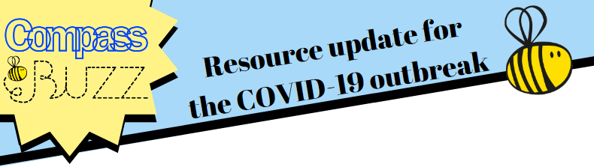
Monday 6th April 2020
Please see below this week’s free resources. These can be shared with colleagues in your school and also with parents and carers where you feel appropriate.
Interactive Resilience Framework (IRF) For Parents and Carers
Hopefully you are familiar with Compass BUZZ’s IRF for use in schools, populated with lots of great ideas for increasing resilience through ‘resilient moves’ which add up and build resilience over time. We are delighted to be able to share an adapted version designed for use at home by parents and carers in response to the COVID-19 outbreak. This is a bumper resource with lots of resources and hyperlinks within it. It is designed to be used over time, as building resilience is a journey. The front page has the framework on, and then the rest of the PowerPoint has suggestions and ideas for each ‘resilient move’. One might pick a few options to start with and keep building. You are welcome to share the whole resource with families, or you might want to share key bullet points each week, taken from different sections, as weekly tips for building resilience. Please speak to your local wellbeing worker if you would like to discuss this further. Double click the icon below to access this resource. If you wish to save it so that you can then share it, right click the icon and select presentation object and then open, from there you should be able to save it.
Staff Wellbeing
This is a challenging time for everyone, including our committed school staff. Whilst supporting their students and families, they are likely to have their own worries, concerns and personal issues. Here is a simple resource about staff wellbeing which you might like to share with you team. Please double click the icon below to access.
Time Capsule
We are living through a moment in history. This free resource encourages people to reflect on the situation and jot down thoughts to look back on in a few years time.
Government Guidance
Finally, I am sure you are all keeping up to date with the official guidance. Here are a couple of links that we have found useful recently:
Mental health and wellbeing during COVID-19.
Free school meals during COVID-19.
Safeguarding during COVID-19.
Vulnerable children during COVID-19.

