PRIVACY NOTICE FOR CHILDREN
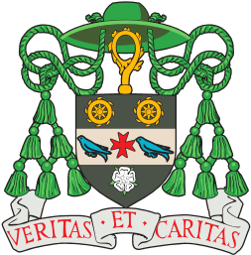
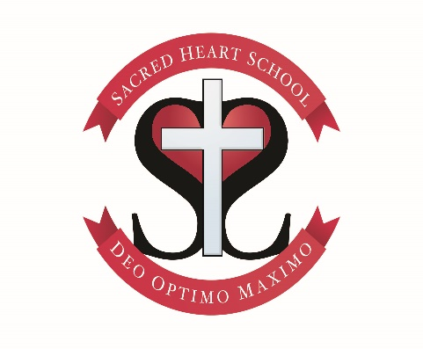

Your school has information about you and we want to tell you all about this. This may seem a little strange at first but it is very important, even from a young age, that you understand what happens with your information. If you have any questions, or you would like some help in understanding this, ask an adult for help – you can ask your teacher, your parent, someone in the school office or Mrs Ashworth.

Some of the information that school has about you tells us who you are such as your name and your address. School has other information about you such as your date of birth, your parents’ names and information about any allergies you may have. This information is called ‘personal data’.

Your school needs this personal data to do lots of things for you while you are here at school such as making sure you are cared for, booking trips, ordering school dinners and telling your parents about how you are doing at school. Because we collect all of this information and make decisions about how we use this information, school is called a ‘data controller’. It’s quite an important name! It also means that we need to take very good care of the information we have about you.

You may already have learned about e-safety in class and why you mustn’t give your passwords to anyone else. Well, this is the nearly same thing – we mustn’t use your personal information in ways we shouldn’t and we need to protect it very well.

Sometimes we do need to give information about you to other people. We might need to tell the school nurses your name and your date of birth so that they can come along to school to measure you. We might need to give your name to the people who run IT programmes such as Mathletics or BugClub so they can set you up to use it. We will only give your information to someone else if the law tells us we can. If not, we will ask your parents for permission.

Why do we collect and use your information?
By law, we have to collect and use some of your personal data. We need the information in order to obey laws such as child protection, which means keeping you safe and well. We also have to use your information because we are a school and you come to school to learn. Sometimes there are other reasons we use your information such as making sure you have everything you need at school to support you and if you have a problem, by making sure you have the help you need. We only use the information we need to be able to be a school.

What information do we have and how do we get it?
When you first start at school, your parents or carers fill in a form. This has lots of information about you like your name, your date of birth, your address and your religion. We also ask your parents or carers to tell us more information before you arrive at school so we can look after you such as any allergies you may have. So nearly all of the information we have is given to us by your parents and carers.

Sometimes other people give us information about you. You may get poorly and need to go to hospital for an illness – sometimes the hospital or a doctor might write a letter to us telling us what is wrong and also what we need to do to help you get better.

All of the information we hold about you fits in to a type of information and these are the types of the information we have about you:

- Personal – this means belonging to you only such as your name and date of birth
- Contact information – addresses and telephone numbers of people (usually your parents or carers) we need to contact
- Characteristics – this is information like your country of birth and the languages you speak
- Attendance information – we record if you have not been to school (when we do the register)
- Assessment information – we record how well you are doing in school
- Health and medical information – information about if you are allergic to anything or you are poorly or had an operation
- Special Educational Needs and Disability (SEND) – if you need any extra support with learning
- Behavioural information – we record information if you have not behaved properly in school
- Photographs – for example, we put these in our newsletter or on the boards in classrooms
- Operational – some of our schools use CCTV to make sure school is safe so you are on the CCTV video
- Legal – for example we record how you travel to school
- Safeguarding information – information used to make sure you are safe and well

Some of your personal data is extra special. This is called ‘special category data’. The special information school has about you is about your religion – if you are Catholic or not, information about your health and your ethnicity (this means where you come from and has a connection with the colour of your skin so you might be White Irish or Black Chinese). Schools uses this information and gives it to the Department of Education so that they can make sure everyone is included and everyone has the same opportunities.

We use your special information so we can do things as a school such as take care of you. We need to know if you are Catholic or not because we are a Catholic school and this matters when your parents apply for you to come to school.

How long do we keep your information?
When you first come to school we collect lots of information about you that is used all the time you are at school with us. When you change schools, we will pass some of this information to your new school. We will also keep it for some time after you have left. We use a big list that tells us when we need to stop holding your information and when we must get rid of it. When we don’t need it, we never just throw it in the bin – you may have seen a shredder in school or a big box with a lock on – this is so any papers that go in that box can be taken away and shredded.

We hold your information on some of the schools computers too but only certain people can use this information – all of the computer systems need passwords to log in to them and even when people have logged in, they only have access to what they need to do their jobs. All the information on our computers is also deleted properly too when we don’t need it.

Do we share your information?
Yes we do but not all of your information and we only share it with certain people so that they can do their job. So we wouldn’t give all of your information to the dinner ladies because they don’t need it all. We are only allowed to share your information if the law says we can or we have to ask permission from your parent or carer to share it.

Some of your information is shared with the Department for Education. This is part of the Government that controls all schools. They ask us for your information to make sure we are doing our job as a school, to check that all the children in the country are at school and support is available to those children who need it.

We also share you information with these other people:

A new school you go to | School Governors
People who organise trips and activities for you | The Local Authority (these are the people who look after schools for the Government)
Volunteers who come into school to help | The Diocese of Leeds who looks after all the Catholic churches in Leeds
People who run our IT programmes | Any students that come into your school to learn how to teach for example
People who help look after you such as school nurses | People who will give you extra support if you need it
Other people who work in school
Your rights (this means the things you can do or have because the laws says you can)
You have the right to understand what information school uses about you, which is why we have written this for you. You could ask for some of the information school has about you to be erased or ask us to stop using it but only if it is allowed by law. If the information we have about you is wrong, you can ask us to put it right. You can also ask us to send your information to another company. If you want to know about the information we have about you, you can ask us that too.

If you have any questions about the information that school uses, or you need help understanding this, or you want to complain about how we use your information, you can speak to anyone in school. Your Headteacher is in charge of the personal data at school. We also have a Data Protection Officer who you can ring on 01943 883 000 or email dpo@bwcat.org.

If you have a problem with your personal data and we cannot solve your problem, you can make a complaint to the ICO (Information Commissioners Office). The ICO controls the people and organisations who use personal data (information about you). You can telephone them on 0303 123 1113, Monday to Friday between 9am and 5pm (but not on bank holidays) or visit https://ico.org.uk/concerns/handling/ on their website.

Sending your information to another country
This might sound strange at first but sometimes there are companies that work in other countries (not the UK) and all of their information travels through IT systems and the internet. Sometimes, we may need to send some of your information to countries which do not have the same level of protection for personal information as the UK does. For example, we may keep your personal information in cloud storage (this is where information is stored and kept) which is abroad; or communicate with you about your parent or carer by email when you are on holiday.

We will only send your personal information to a country which has a safe level of protection, or where we have done things and checked to make sure your information is safe.

We hope that you now understand a little bit more about what personal data is and what school does with yours – isn’t it a bit more interesting than you could have imagined?!
Contact
Mrs Ashworth
Sacred Heart Catholic Primary School, Valley Drive, Ilkley, LS29 8NL

