PRIVACY NOTICE FOR PUPILS AND FAMILIES
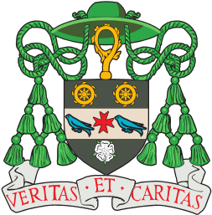

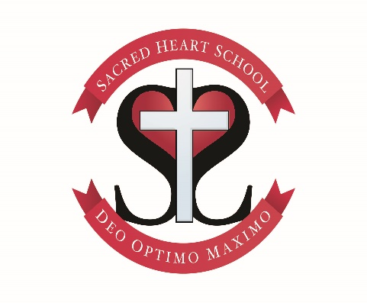

The purpose of this privacy notice is to explain how you and your parents/carers’ personal information may be used.
We take your privacy seriously and you can find out more here about how we gather and use your personal data – that includes the personal data we already hold about you now and any additional personal data we might collect about you, either directly from you or from a third party. We will always take into account your interests and rights when processing your personal data.

When we say ‘we’, this means Sacred Heart Catholic Primary School and The Bishop Wheeler Catholic Academy Trust (the Multi Academy Trust that Sacred Heart Catholic Primary School belongs to).

Who processes your personal information?
Sacred Heart Catholic Primary School collects information about you and we make decisions about how and why it is processed. This means we are a ‘Data Controller’. The Headteacher acts as a representative for the school in carrying out the responsibilities of a data controller; they can be contacted on 01943 609578 or office@sacredheart.bradford.sch.uk if you have any questions.

In some cases, some of your personal data will be processed by a third party ‘data processor’, such as the Government (this means that they handle your information on our behalf). This will only be done with your consent, unless the law requires us to share your data. When someone else processes your data for us, we make sure they are also handling it lawfully.

Why do we collect and use your information?
By law, we have to collect and use some of your personal data. We process it in order to obey laws such as child protection, safeguarding and welfare. We also have to use your personal data to fulfil our public task to provide an education.
We may also have a legitimate reason for processing your personal data, such as CCTV footage, in order to provide a safe and secure environment or to inform you of news and events. These are the reasons why we use your personal data:

For school admission purposes | to monitor and report on pupil progress; | to communicate with parents and carers;
to provide appropriate pastoral care; | to provide statutory services; | to assess how well the school is doing;
to assess the quality of our services; | to safeguard children and young people; | to comply with legislation and regulations;
the promotion of our school and Trust; | to support teaching and learning

What data is collected and how
Much of the personal data we hold about you is provided by you; parents and pupils. Personal data may be collected and provided from other sources, such as the previous school attended, or health information on an Educational Health Care Plan, or a letter from the NHS with information about allergies and treatment.

The categories of personal data that we process include:
- Personal – e.g. names, date of birth
- Contact information – e.g. addresses and contact details and emergency contact details
- Characteristics – e.g. ethnicity, language, country of birth
- Attendance information – e.g. number of absences and absence reasons
- Assessment information – e.g. national curriculum assessment results
- Health and medical information – e.g. allergies, long-term conditions
- Information relating to Special Educational Needs and Disability (SEND)
- Behavioural information – e.g. number of temporary exclusions
- Biometric – e.g. photograph used to for identification or for media purposes
- Financial information – e.g. payment records on ParentPay and free school meal eligibility
- Operational – CCTV footage
- Legal – e.g. mode of travel to school
- Safeguarding information – e.g. concerns raised by a member of staff

Special protection is given to certain kinds of personal data that is particularly sensitive. This is called ‘special category data’. This is personal information about racial or ethnic origin, political opinions, religious or philosophical beliefs, genetic information, biometric information, health information, and information about sex life or sexual orientation. The reasons why we use this type of data are:

Substantial public interest - the processing is necessary for reasons of substantial public interest.
Vital interests - to protect the vital interests of any person where that person cannot give consent e.g. if they are seriously hurt and are unconscious.
Medical and health purposes – ensuring high standards of health care.
Social protection – the processing is necessary for safeguarding, child protection and welfare purposes.

Normally we won’t need your consent to use your personal data but when consent is required, the school will provide you with specific information explaining the details and how the data will be used. Where the processing of your data is based on your consent, you have the right to withdraw this consent at any time. Details of how to do this are on the Consent Form.
How long is your personal data kept?
We hold personal data on past, present and future pupils and their families from the point that an application or request to start school is made through our school or the Local Authority.

The school does not store personal data indefinitely; most personal data is only stored for as long as is necessary to complete the task for which it was originally collected. Some personal data such as child protection information is retained for 25 years. Personal data relating to pupils at Sacred Heart Catholic Primary School and their families is stored in ways recommended by the Information Management Toolkit for Schools.

Will your personal data be shared?
We control access to personal information, giving access only to people who need particular information to do their jobs, and only when they need it. We do not share information about you with anyone without consent, unless the law and our policies require or allow us to do so. We sometimes share information through a legal duty to do so, such as safeguarding and child protection information.

We are required by law, to provide information about our pupils to the Government’s Department for Education (DfE) as part of statutory data collections; the school census and early years’ census. To find out more about the pupil information we share with the Department, for the purpose of data collections, go to https://www.gov.uk/guidance/data-protection-how-we-collect-and-share-research-data.

We use various third party IT tools in school which help us achieve our objectives and ensure that pupils’ best interests are advanced. We use software to track and report on attainment and progress. We use financial software to manage school budgets, which may include some pupil data. We use systems to record personal data including information about parents and carers for emergency contacts. We also use your contact information to keep pupils, parents and carers up to date about school events. We also share some of your personal data with the following groups of people to fulfil our duties as a school, such as:

Statutory organisations such as the DfE, HMRC (such as for VCS gift aid) | Pupils’ destinations upon leaving the school
Educational support providers such as on day and residential trips | The Local Authority
Volunteers involved in supporting teaching and learning within schools | The NHS (such as school nurses)
Third party providers of IT programmes such as ParentPay, Googlemail, Tapestry | Trustees, Academy Councils and Directors
External agencies relating to SEND, health, child protection, welfare and safeguarding | The Diocese of Leeds
Examination Boards and Assessment bodies | Relevant Trust staff
Educational programmes to support pupil learning | Third party students such as School Direct trainees, Apprentices
Your rights
You have various rights under Data Protection Law to access and understand the personal data we hold about you, and in some cases to ask for it to be erased or amended or for us to stop processing it. However, your rights are subject to certain exemptions and limitations.

If you would like to access your personal data, or ask us to amend it, or would like it to be transferred to another person or organisation, or have some other objection to how your personal data is used, please contact the school. We will respond to any such written requests within one month. If this is not possible, we will write to you explaining why. There is ordinarily no charge for this. However, if the request is excessive or similar to previous requests, we may ask you to reconsider or charge a proportionate fee, but only where Data Protection Law allows it.

You should be aware that certain data is exempt from the right of access. This may include information which identifies other individuals, or information which is subject to legal privilege.

If you have a concern about how Sacred Heart Catholic Primary School is processing your personal data, please speak to the Headteacher at the school, or the Trust Data Protection Officer: telephone 01943 883 000 or email dpo@bwcat.org. If you cannot resolve the issue in this way you can make a complaint to the ICO (Information Commissioners Office). You can telephone them on 0303 123 1113, Monday to Friday between 9am and 5pm (excluding bank holidays) or visit https://ico.org.uk/concerns/handling/. More information about your rights can be found at https://ico.org.uk/for-organisations/guide-to-the-general-data-protection-regulation-gdpr/individual-rights/

Sending data outside the UK
We may need to send some of your personal data to countries which do not have the same level of protection for personal information as the UK. For example, we may store your personal data on cloud computer storage based overseas; or communicate with you about your child by email when you are overseas (for example, when you are on holiday).

We will only share your data with countries the UK Information Commissioners Office deems safe and have adequate protection in place., or where we have put in place our own measures to ensure adequate security as required by data protection law. These measures include ensuring that your personal information is kept safe by carrying out checks on our partners and suppliers.

When we use third party service providers, we disclose only the personal information that is necessary to deliver the service, and we have a contract in place that requires them to keep your information secure.

Data Protection Officer
The Trust’s Data Protection Officer (DPO) is Jemma Johnson. The role of the DPO is to provide advice on data protection and to monitor the school’s data protection procedures and to ensure they are compliant with the GDPR. The Data Protection Officer can be contacted at dpo@bwcat.org or 01943 883000.

Contact
If you wish to speak to us regarding your data, please contact Alison Ashworth on 01943 609578 or office@sacredheart.bradford.sch.uk.

Sacred Heart Catholic Primary School, Valley Drive, Ilkley, LS29 8SB

